Song Art Museum to present a major retrospective of Hsiao Chin, “The Artist as Astronaut: Hsiao Chin”, co-organised by Hsiao Chin Foundation and 3812 Gallery

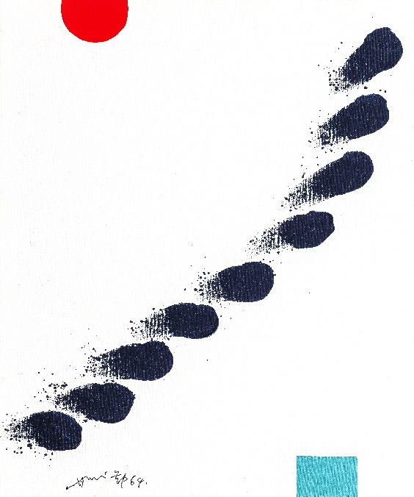
Hsiao Chin, Cause of Life-1, 1964, Acrylic on canvas, 60 x 50cm
Courtesy of Hsiao Chin Foundation

"The Artist as Astronaut: Hsiao Chin" is a large-scale retrospective exhibition of Post-war Chinese Abstract artist, Hsiao Chin (b. 1935), to be held at the Song Art Museum, Beijing from 13 March to 13 June 2021. 3812 Gallery, Hong Kong’s foremost gallery specialising in Chinese Contemporary Art as well as an exclusive agent for Hsiao Chin, is honoured to work with the Hsiao Chin Foundation as co-organisers of this exhibition.

Founder of the “Punto International Art Movement”, Hsiao Chin is a prominent figure in the international Post-war art scene, active in both Eastern and Western art circles. Hsiao garnered recognition from the Western art world through his employment of Eastern aesthetics to create a distinctive style in the field of abstract painting. Co-curated by Calvin Hui (co-founder of 3812 Gallery) and Philip Dodd (British curator), the exhibition features 79 works, including paintings, ceramics and sculptures by the octogenarian artist across nearly seven decades of his career, from the 1960s to the present day and taking place across China, Europe and United States.

For half a century, Hsiao Chin was constantly on the move. His imagination runs beyond this world into outer space, and the universe has been a core theme of his artistic study and practice for much of his career. Hsiao Chin first created the Universal Energy series during the Punto period. He stated that his exploration of the mysteries of the universe and his pursuit of living energy resulted in the pictorial development of his philosophical ideas and joyous emotional expressions. This extraordinary imagination connects him to both the present and the past. The last great moment when outer space preoccupied artists was the late '50s and '60s. Hsiao Chin's greatest works span across these two periods, a time when space and the void have become topics of interest to scientists as to philosophers.

In many of his artist’s statements made in or after 2000, Hsiao Chin has repeatedly emphasised the inspirational impact of the “grand energy of the universe” on his art practice. The statement not only refers to the internal energies of the galaxies and planets, but rather underscores the harmonious relationship between human lives and the universe. Additionally, it also reflects the profound spiritual power that enables the coexistence of all lives, objects, cultures, and religions with or without a tangible form.

Hsiao Chin commented that he might have been an astronaut if had he not been an artist. He says, “My decades of research and experience in Eastern and Western art, philosophy, religion, mysticism and space civilization have formed a foundation for my interpretation of the essence of the universe and the cyclical evolution of life forces. The broad nourishment to be found within these great ideas is the source of my creative inspiration, regardless of the creative themes or titles. My artworks place a greater emphasis on the cosmic unity connected to human spiritual life, and the sentient energy that resides deep within all tangible and intangible life, forms of matter, cultures and religions, driving their motion and coexistence. That is why I call myself an astronaut, a man of the universe.”

In addition to paintings, ceramics and sculptures, the exhibition will debut two immersive digital art installations by Hong Kong TECH-iNK artist Victor Wong (b. 1966), specifically made to accompany Hsiao Chin’s works on this occasion. As an integral part of the exhibition, Wong’s works on display demonstrate the impact and legacy of Hsiao Chin in the broader context of Contemporary art.

To fully explore the artist’s philosophical thoughts and creative ideas, the exhibition will also show a number of objects selected by Hsiao Chin and historical documents selected by the curators, reflecting on Hsiao’s life experience across the decades and his association with European artists, Buddhism and Taoism. These vitrines are a revelation of Hsiao Chin’s personal story and re-asserts his active involvement in Modern Art throughout the decades.

Philip Dodd, co-curator of the exhibition, says, “My sense is that Hsiao Chin’s imagining of himself as a citizen of outer space was his singular way of rejecting the commercialism and materialism that saturated and still saturates the world. To put it this way, to imagine himself as an ‘alien’ gave him a point of view beyond this world and its story of worldly success; it allowed him to imagine in his painting new worlds, to explore inner and outer space.”

A wide range of educational programs will be offered in conjunction with the exhibition, including lectures and webinars. Exploring Hsiao Chin's influence on Post-war Asian art and the artist's first immersive exhibition at the Song Museum, Sotheby’s Hong Kong will host a webinar on “Contemporary Conversations: The Artist as Astronaut – Hsiao Chin” on 16 March with Felix Kwok (Head of Modern Art at Sotheby’s Asia), Calvin Hui (co-founder and art director of 3812 Gallery, and co-curator of this exhibition), and Wang Duan (Vice President of Huayi Brothers Art and director of Song Art Museum) in Mandarin.

Calvin Hui adds “When I take in Hsiao Chin's paintings and consider his journey in life, my heart sways between the vivid and chromatic effects of his works. Hsiao Chin viscerally promotes Eastern aesthetics and religious philosophy to the world, therefore influencing humanity through the energy that he emanates, and then brings a powerful spiritual strength back to his homeland. Akin to a circle, Hsiao’s journey epitomises an eternal process of departing and returning to the original point.”

Exhibition Date: 13 March to 13 June 2021
Opening hours: Tuesday to Sunday 10 am to 6 pm (with last entry at 5:30pm)
Address: Song Art Museum, Gelasi Road, Tianzhu Town, Shunyi District, Beijing China
Press Enquiry: David Yu (Sutton), davidy@suttoncomms.com
Emma Chan (3812 Gallery), emma.chan@3812cap.com
Press kit: https://egnyte.suttoncomms.com/fl/831SrqzFJ1
Ticketing information (in Chinese): https://bit.ly/3v75NYm

Sotheby’s Talks - Contemporary Conversations: The Artist as Astronaut – Hsiao Chin
Date: Tuesday, 16 March
Time: 5pm - 6pm
Language: Mandarin
Panelists: Felix Kwok, Head of Modern Art at Sotheby’s Asia
Calvin Hui, co-founder and art director of 3812 Gallery, and co-curator of this exhibition
Wang Duan, Vice President of Huayi Brothers Art and director of Song Art Museum
RSVP: https://rsvp.theworldsbest.events/_0g581

About Hsiao Chin

Hsiao Chin (b.1935) is a master artist recognised as a pioneer of Modern Abstract Art in China. With a group of artists who shared his aesthetic vision, in 1955 Hsiao Chin co-founded the Ton Fang Art Group, the first Post-War Chinese Modern Art group, which blended techniques from traditional Eastern art with Western Modernism, while promoting Chinese Modern Art overseas. In 1956, Hsiao embarked on a series of travels in America and Europe, first moving to Madrid and finally settling in Milan, where he has lived for over half a century. In 1961, Hsiao Chin co-founded the Punto International Art Movement, the first ever international Avant-Garde art movement initiated by an Asian artist with the aim of promoting Oriental philosophy of “calm observation”.

Having lived and worked abroad for 60 years, Hsiao has successfully integrated his extensive studies of Western aesthetics and Eastern philosophies, as well as his interest in space science, in his artistic creation. Hsiao Chin has had various solo and group exhibitions globally in prominent museums and art centres including Mark Rothko Art Centre (Daugavpils), Guimet National Museum of Asian Arts (Paris) and National Taiwan Museum of Fine Arts (Taichung). His works can be found in the collections of the Metropolitan Museum (New York), National Art Museum of China (Beijing) and Galleria Nazionale d’Arte Moderna (Rome).

About Victor Wong

Victor Wong (b.1966) is best known for his digital work and special effects. He invented and created A.I. Gemini, becoming the first-ever artificial intelligence ink artist in the world in 2018. In 2019, Victor's Escapism series was unveiled at INK NOW Taipei Art Expo in January, marking the beginning of the TECH-iNK era. In April 2019, 3812 Gallery London held his debut exhibition in Europe, Far Side of the Moon. Within one year, 3812 Gallery presented Wong’s TECH-iNK in many cities internationally, including London, Hong Kong, Taipei, Shanghai, and Nanjing. TECH-iNK has brought ink art to a whole new level, expanding the possibilities that technology can offer creativity whilst mindfully exploring the challenges of this relationship.

His works are held by numerous important private collectors, including the Uli Sigg Collection in Switzerland. The first A.I. ink painting, Escapism 0001, was featured on the cover of Cathay Pacific’s inflight magazine Discovery in January 2019 and subsequently collected by the airline. In May 2020, Wong was commissioned by SAMSUNG to create a new work, The Fauvist Dream of Gemini 03. The digitalised version of the work is featured in SAMSUNG THE FRAME 2020 and was exhibited at Lane Crawford at ifc mall in Hong Kong.

Victor’s visual effects (VFX) production company, vfxNova, has produced over 800 TV advertisements and designed special effects for over 100 films from Hong Kong and Hollywood, including Iron Man, Fantastic Four, The Nightmare Before Christmas 3D, Rise of the Legend, CJ7, and Initial D, among others.

About Song Art Museum

Song Art Museum is a private art museum in Beijing established by world-renowned art collector Wang Zhongjun in September 2017. The museum covers an area of 22,000 square meters with its courtyard surrounded by 199 evergreen pine trees, providing an external vitality of Song Art Museum. ‘Song’ comes from the Chinese word for pine trees, (松樹, sōng shù), a conventional Chinese symbol of longevity, immaculacy and peace. Similarly, Wang hopes for the Song Art to be a space where different artworks can harmoniously coexist and can be impartially examined. The museum transforms everything into geometry, purity, akin to what Chinese philosopher Lao Tzu once said, "govern without intervention" from the outside to inner. Through its purity, the museum welcomes any kind of contemporary art to show its vitality without any compromise.

Since its opening in 2017, Song Art Museum has held several large Chinese artwork exhibitions and will continue to push forward the development of Chinese modern art. The museum also actively exchanges ideas with International modern arts (projects) by hosting a series of high-quality exhibitions coupled with collection, research, education, publication and public events.

About 3812 Gallery

3812 Gallery was named after the co-founders were inspired by the infamous La Vallée Blanche at an altitude of 3812 meters while skiing in Chamonix in the Alps. Looking back at the past ten years, 3812 Gallery has been deeply rooted in Hong Kong. It always adhered to courage and perseverance to take on different challenges.

Co-founded by Hui and Mark Peaker in Hong Kong in 2011, 3812 Gallery is recognised as the city's foremost gallery dealing in Chinese contemporary art as well as an agent for the Post-war Chinese Abstract Art master Hsiao Chin. The gallery actively promotes contemporary ink art in the international market.

Launching 3812 Gallery firmly onto the international stage, in 2018 it opened the new flagship space, 3812 Gallery London, in the exclusive St James' arts district. Coinciding with the 3812 Gallery's 10th anniversary in 2021, it opened a brand new 3,600 square feet space to expand into a new cultural and artistic landscape as the foremost international gallery in Hong Kong. The gallery will also exclusively represent three Modern British artist estates – Francis Davison, Terry Frost and Albert Irvin in Asia, and has five outstanding Hong Kong contemporary ink artists on the roster – Chui Pui Chee, Chloe Ho, Kassia Ko, Raymond Fung and Victor Wong - establishing the gallery's vision to develop into an international gallery.
3812 Gallery is dedicated to fostering cultural understanding of Chinese contemporary art with "Eastern Origin and Contemporary Expression". We strive for establishing international dialogue and exchanges by uniting artists, academics, collectors and the general public through our thoughtfully curated art programme. We believe that this sharing of cultural identity is essential in the understanding and appreciation of Chinese contemporary art.

